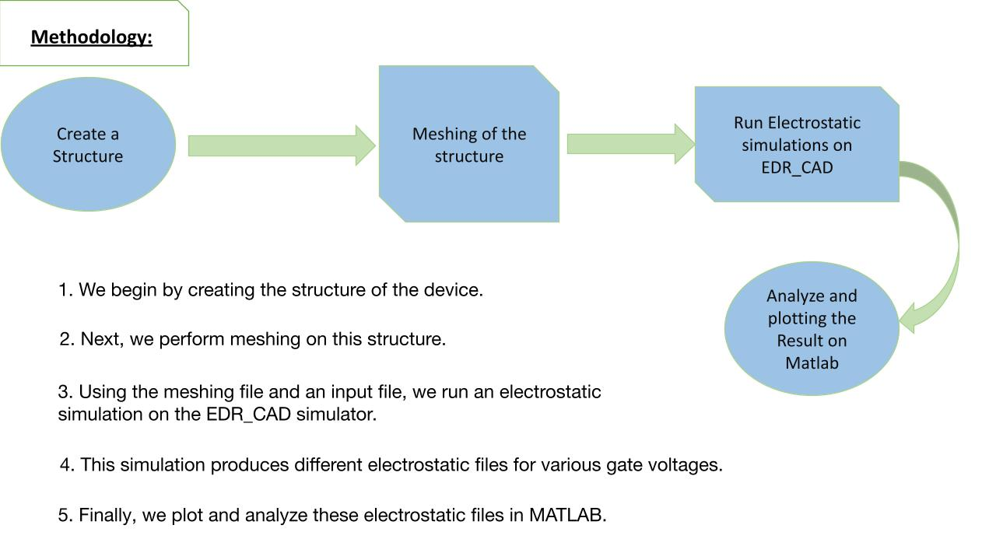

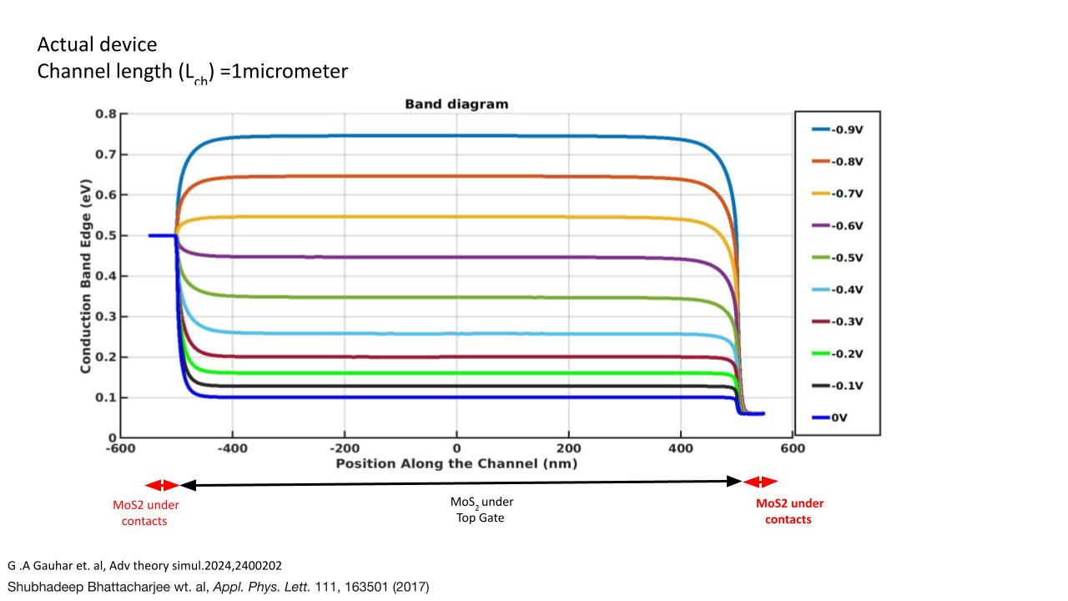

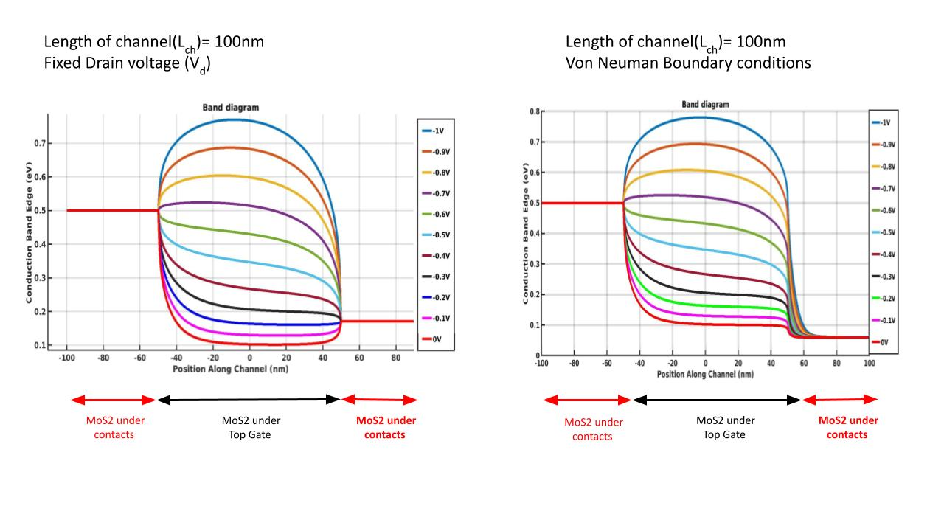

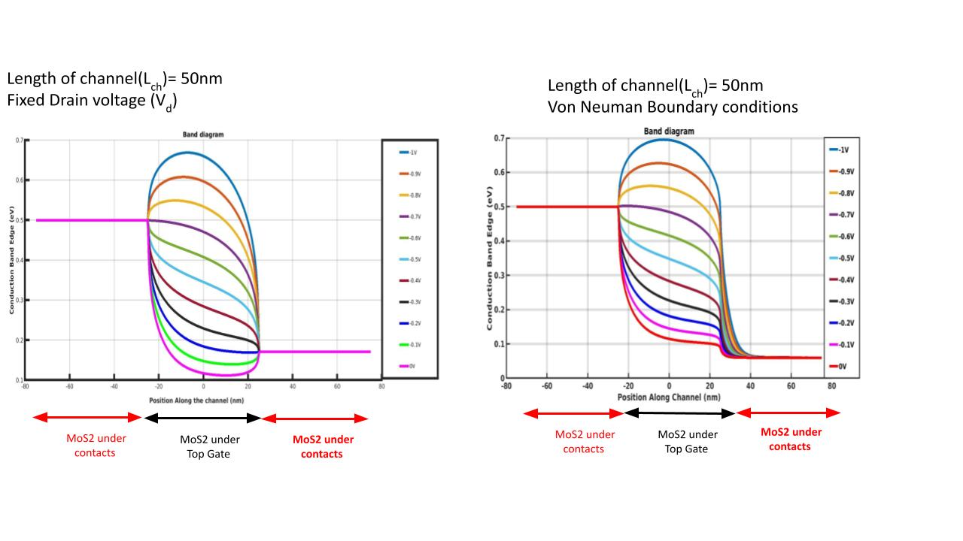

* Channel length = 50 nm
* Doping 2x1016 / cm3
* Vds = 10 mV (Schottky contacts at both ends one side 0.5 eV other side 0.49 eV)
* Dirichlet BC.

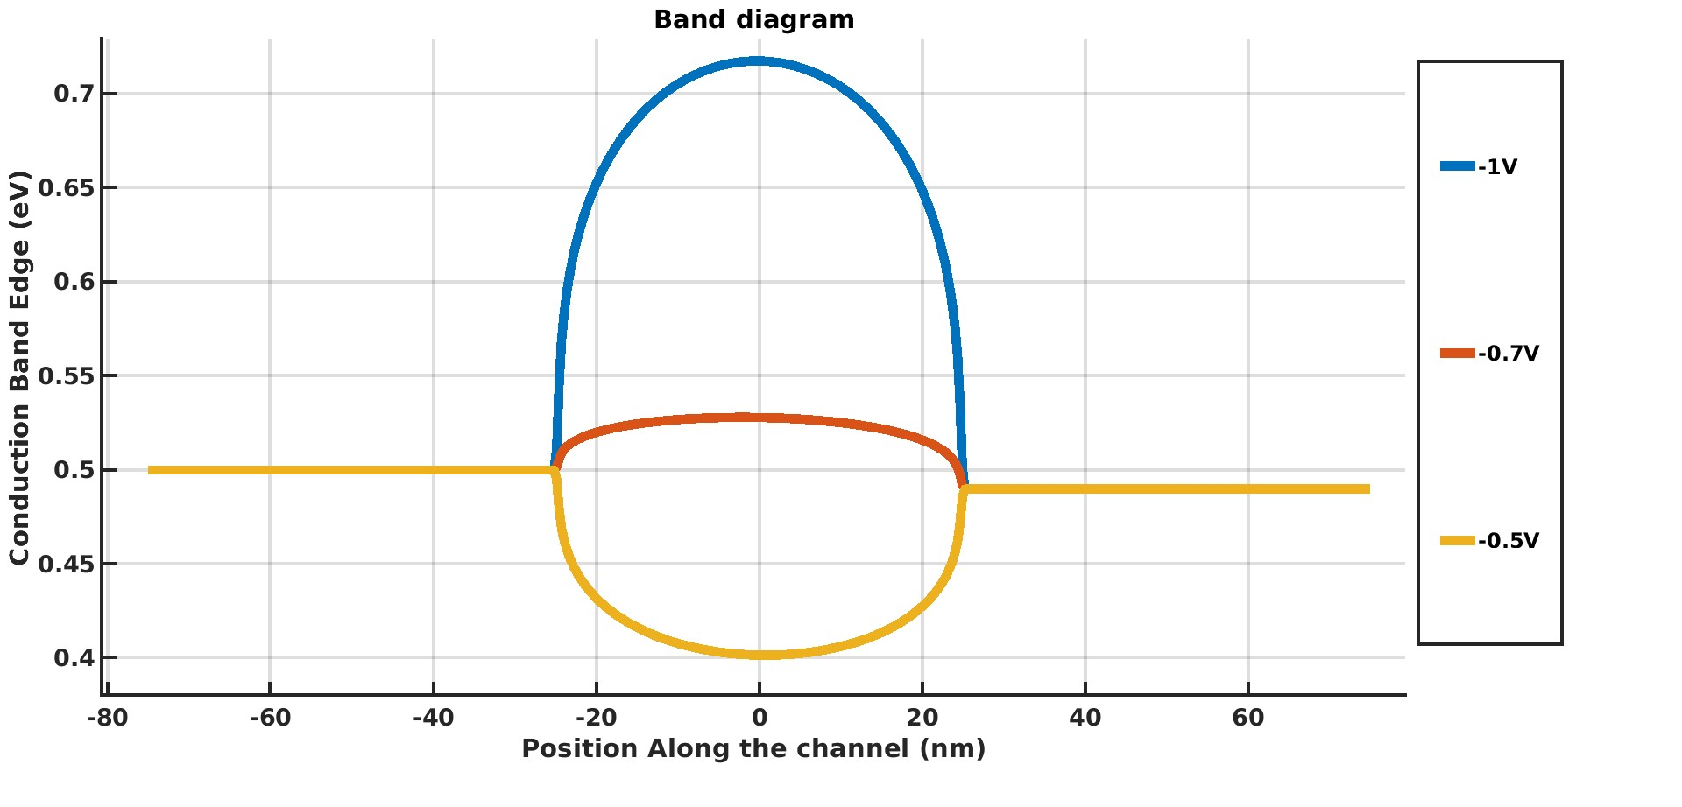

\

* Channel length = 50 nm
* Vg = -1V
* Varying Doping (cm-3)
* Vds = 10 mV (Schottky contacts at both ends one side 0.5 eV other side 0.49 eV)
* Dirichlet BC.

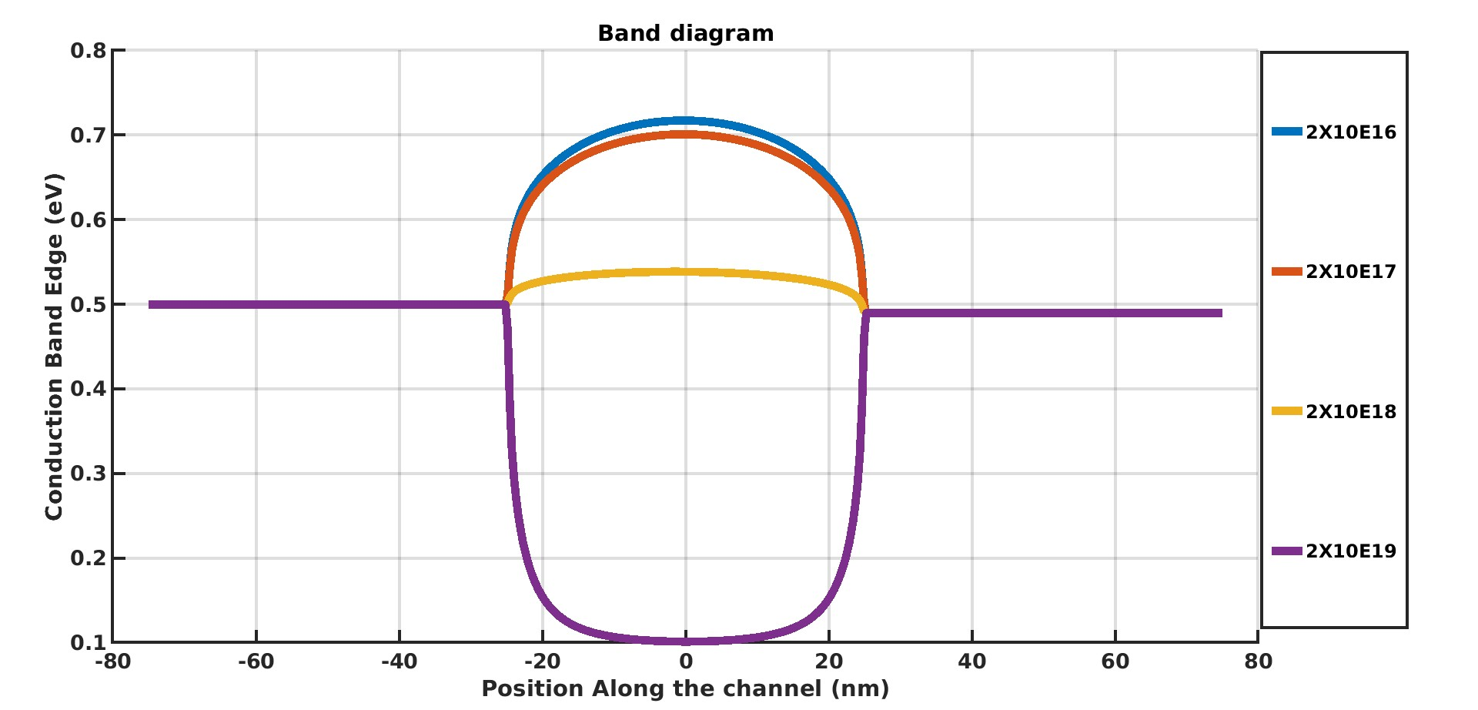

* Channel length = 50 nm
* Vg = -0.7V
* Varying Doping (cm-3)
* Vds = 10 mV (Schottky contacts at both ends one side 0.5 eV other side 0.49 eV)
* Dirichlet BC.

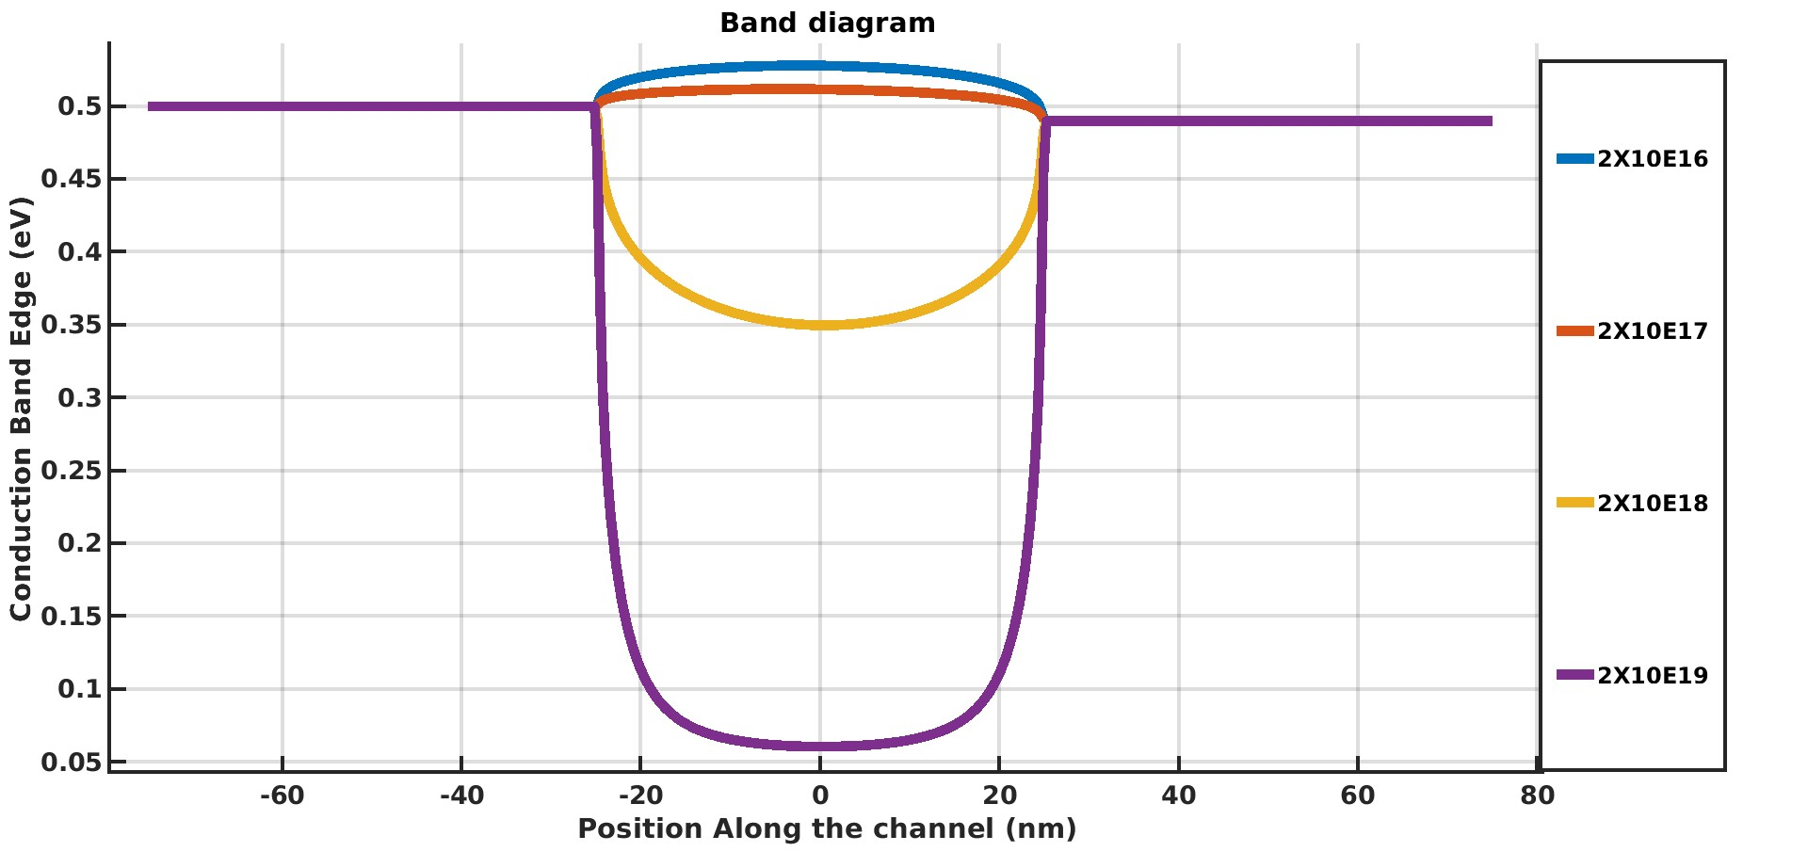

* Channel length = 50 nm
* Vg = -0.5V
* Varying Doping (cm-3)
* Vds = 10 mV (Schottky contacts at both ends one side 0.5 eV other side 0.49 eV)
* Dirichlet BC.

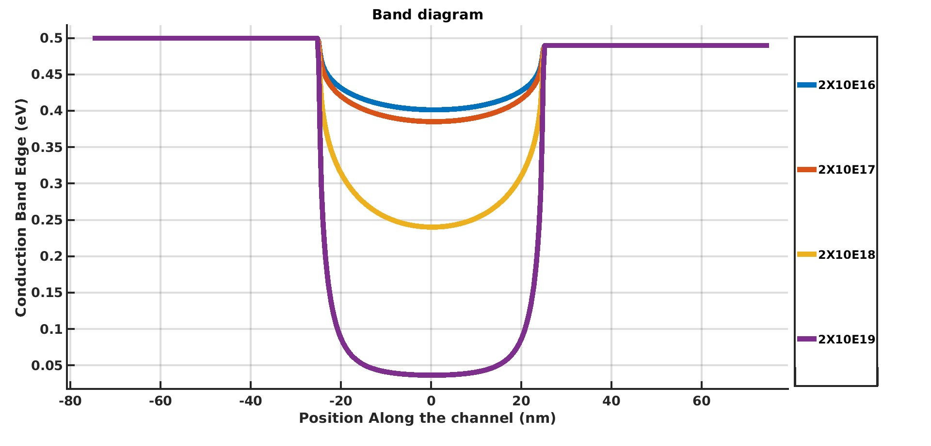

* Channel length = 100 nm
* Doping 2x1016 / cm3
* Vds = 10 mV (Schottky contacts at both ends one side 0.5 eV other side 0.49 eV)
* Dirichlet BC.

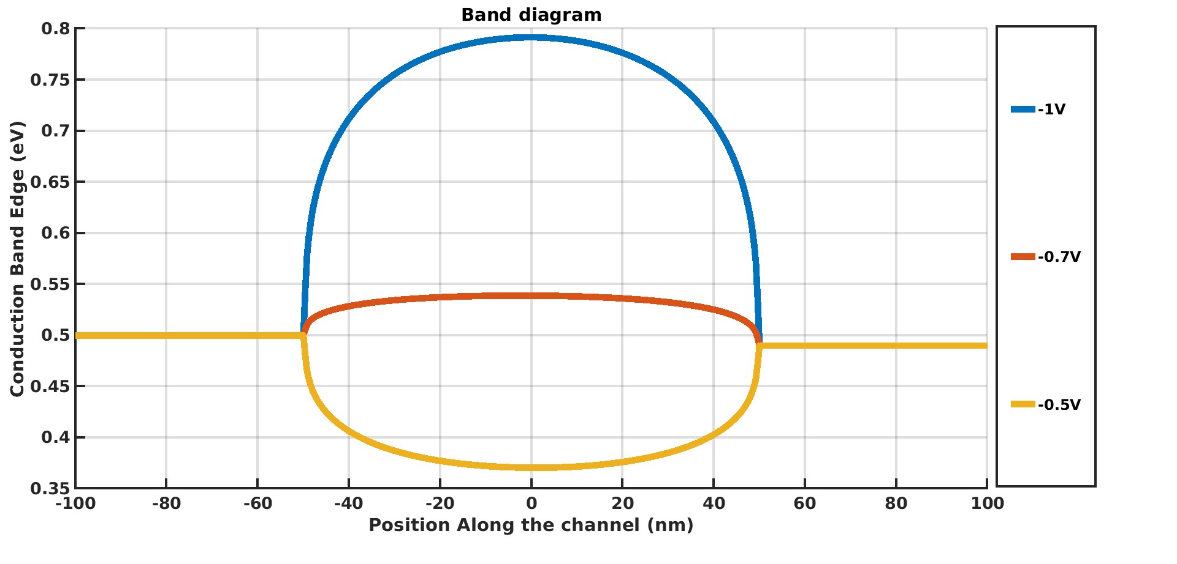

* Channel length = 50 nm
* Vg = -1V
* Varying Doping (cm-3)
* Vds = 10 mV (Schottky contacts at both ends one side 0.5 eV other side 0.49 eV)
* Dirichlet BC.

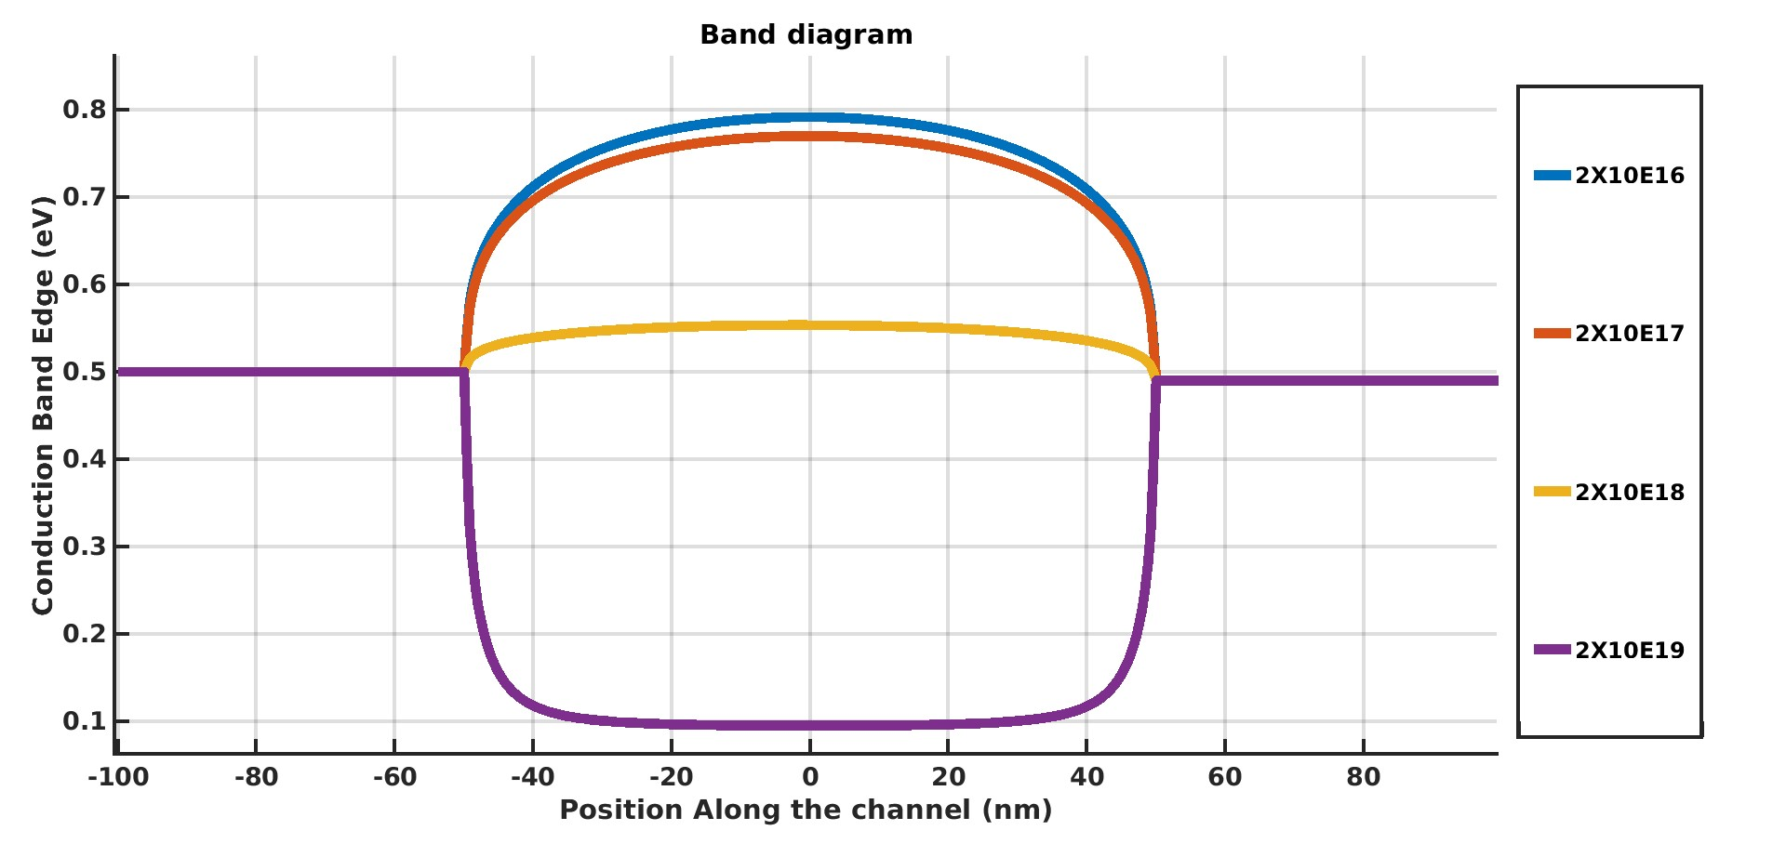

* Channel length = 50 nm
* Vg = -0.7V
* Varying Doping (cm-3)
* Vds = 10 mV (Schottky contacts at both ends one side 0.5 eV other side 0.49 eV)
* Dirichlet BC.

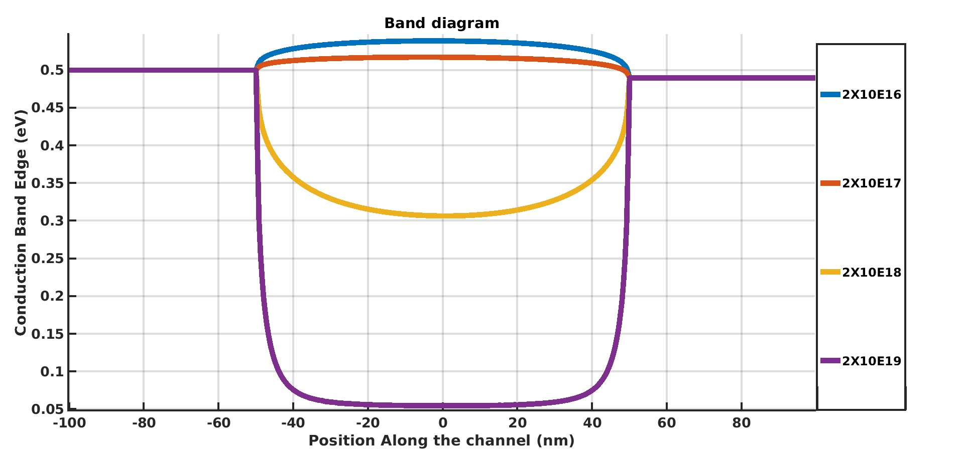

* Channel length = 50 nm
* Vg = -0.5V
* Varying Doping (cm-3)
* Vds = 10 mV (Schottky contacts at both ends one side 0.5 eV other side 0.49 eV)
* Dirichlet BC.

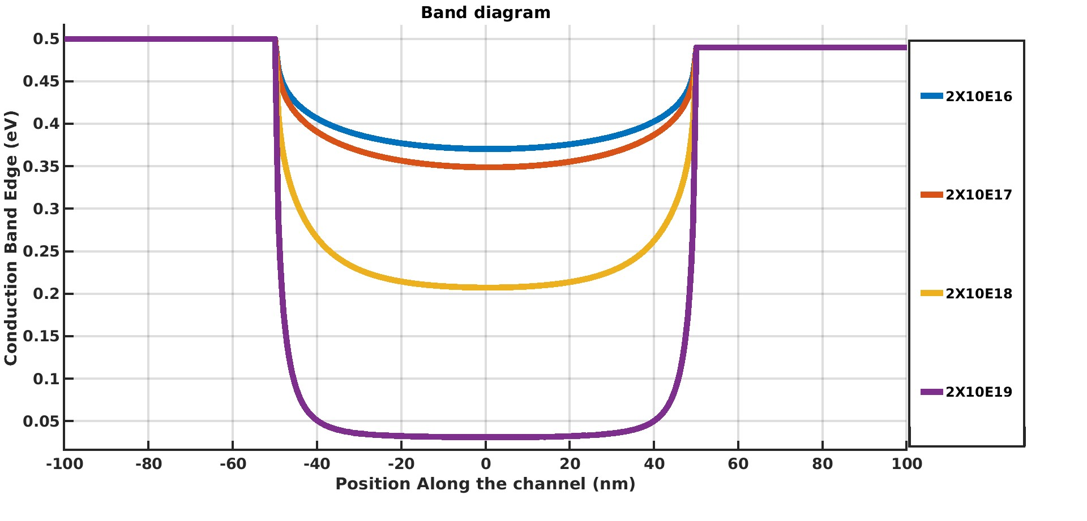

* Channel length = 1000 nm
* Doping 2x1016 / cm3
* Vds = 10 mV (Schottky contacts at both ends one side 0.5 eV other side 0.49 eV)
* Dirichlet BC.

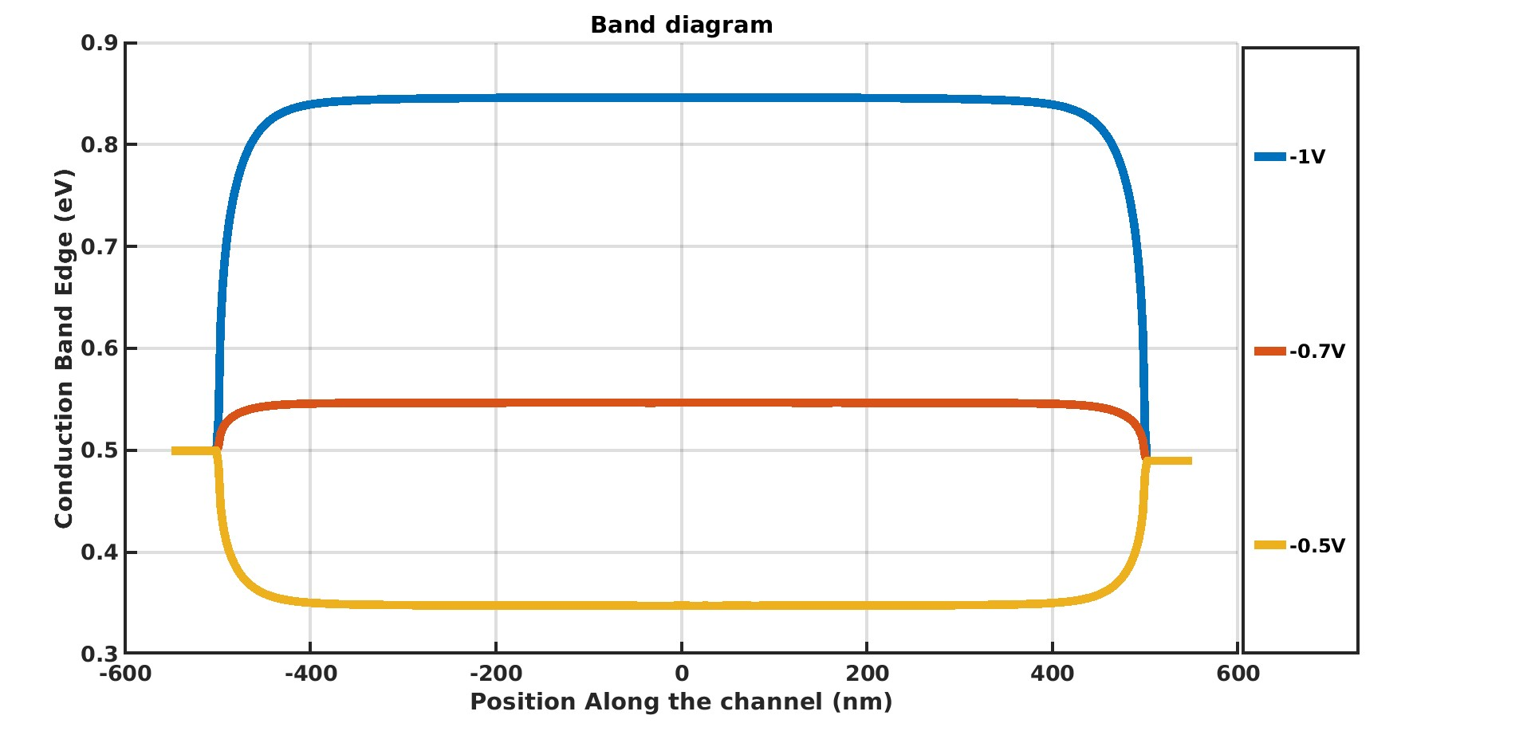

* Channel length = 1000 nm
* Vg = -1V
* Varying Doping (cm-3)
* Vds = 10 mV (Schottky contacts at both ends one side 0.5 eV other side 0.49 eV)
* Dirichlet BC.

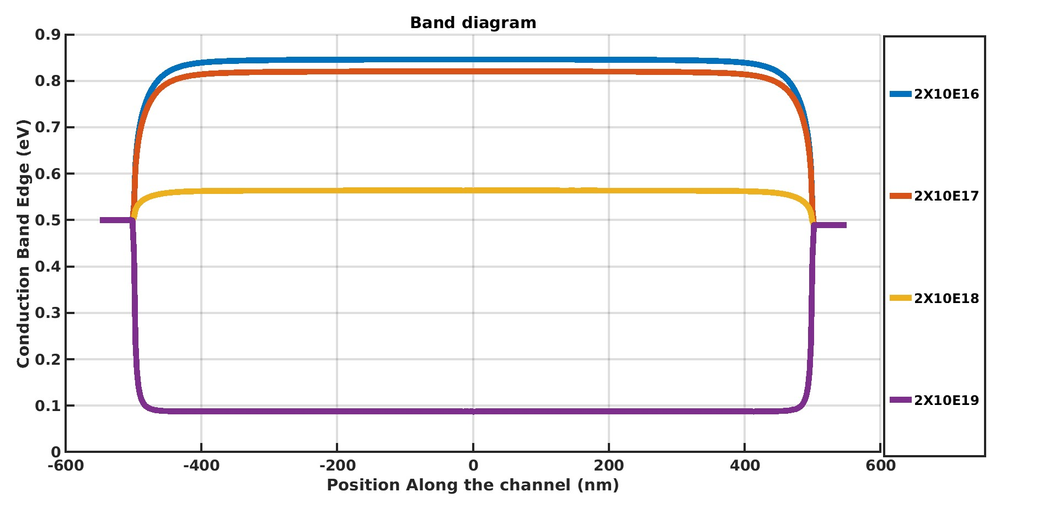

* Channel length = 1000 nm
* Vg = -0.7V
* Varying Doping (cm-3)
* Vds = 10 mV (Schottky contacts at both ends one side 0.5 eV other side 0.49 eV)
* Dirichlet BC

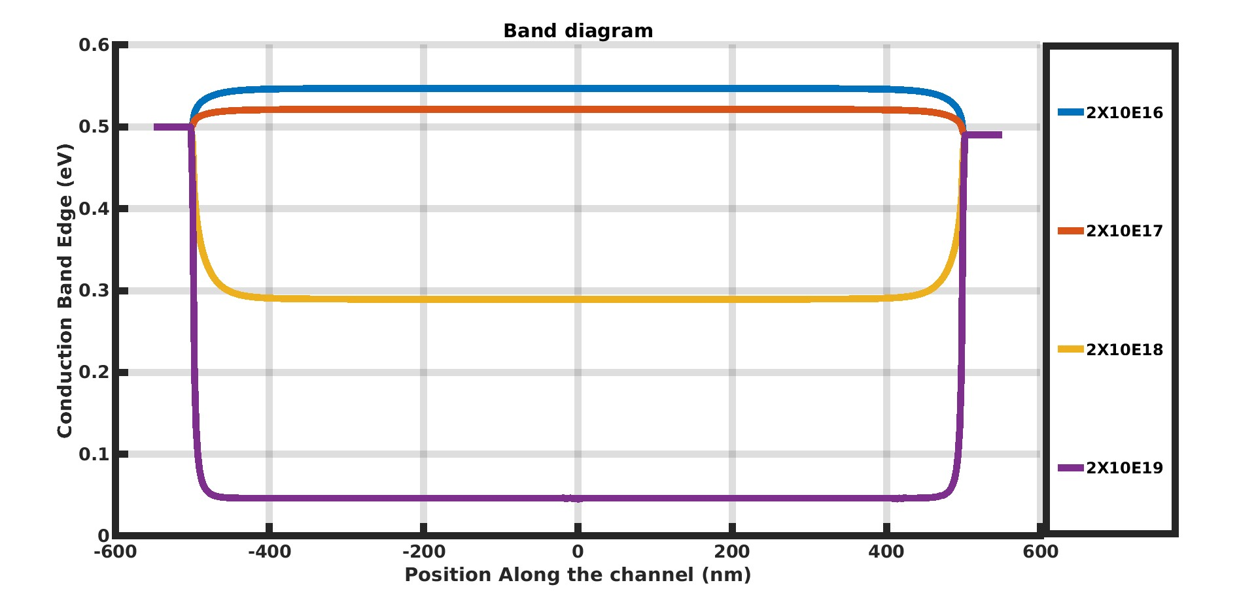

* Channel length = 1000 nm
* Vg = -0.5V
* Varying Doping (cm-3)
* Vds = 10 mV (Schottky contacts at both ends one side 0.5 eV other side 0.49 eV)
* Dirichlet BC

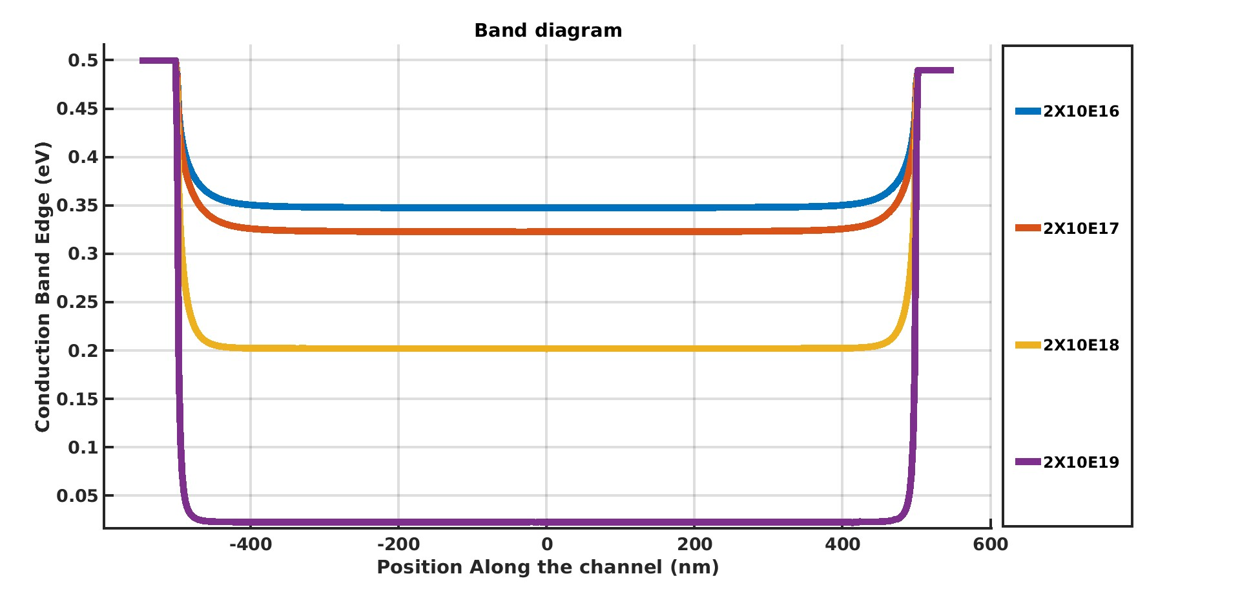

* Vg = -1V
* Doping 2x1018 / cm3
* Vds = 10 mV (Schottky contacts at both ends one side 0.5 eV other side 0.49 eV)
* Dirichlet BC.

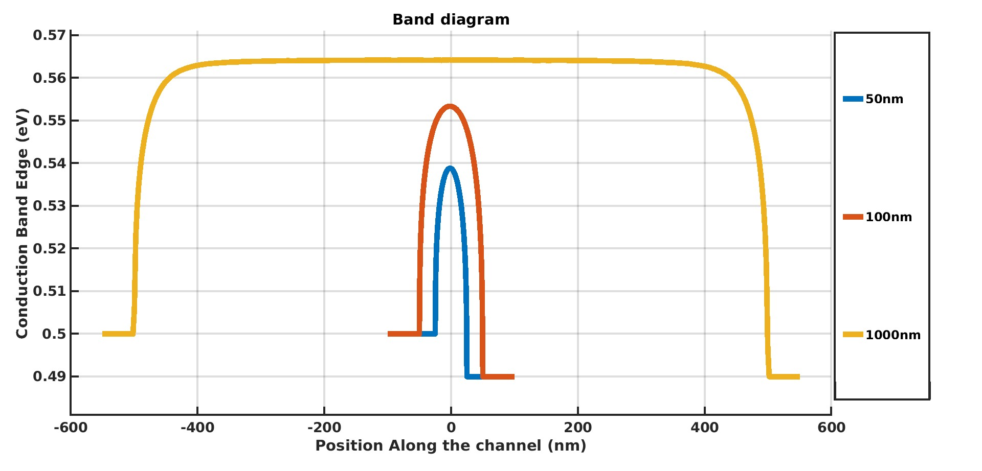

* Vg = -1V
* **Doping 2x1016 / cm3 Value in GA paper**
* Vds = 10 mV (Schottky contacts at both ends one side 0.5 eV other side 0.49 eV)
* For different Channel Length (Lch)
* Dirichlet BC.
* For Lch=300nm, the conduction band edge is at 0.840ev
* For Lch=1000nm, the conduction band edge is at 0.846ev

